Optimal Industry Development Strategy for CountryX

0. Executive Summary

In this report, we aim to uncover the economic path CountryX went through during the period from 2013 to 2018. Specifically, we examine a macroeconomic overview of CountryX from the perspective of Gross Domestic Product (GDP) and Economic Complexity Index (ECI), which reflect countries’ production capability and production structure, respectively. We find that during the period of our interest, CountryX demonstrated a moderate level of economic growth with an annual GDP growth rate of 3.9%, concurrent with a decrease in economic complexity as compared with other major developed economies.

The lack of progress during the period can be partially explained through an analysis of the economic and product complexity structure of CountryX. The product classification system we adopt allows us to measure the realized industry development for various industry groups and to observe that CountryX consistently relied on developing Services and Utilities, Weapons and Raw Manufacturing industries during the period, while developed counterparts and other emerging economies around the globe have adopted much more complex and progressive paths.

Based on our analyses of the opportunity gain and sensitivity of major industry groups, CountryX can further its gains by prioritizing High-complexity Products and Chemicals. We further note that CountryX has a slightly mismatched development strategy that indicates a moderate level of structural optimality based on its complexity level, having an adjusted R-square of around 15.7%. Since a significant positive correlation exists between five-year GDP growth and the structural optimality index of an economy as we define and calculate, CountryX indeed has a suboptimal growth experience as compared with fast-growing economies both on a regional scale and on a global scale, and has the potential to further its economic gains through industrial structure optimization as suggested in the paper.

1. Report Overview

In this report, we aim to uncover the economic path CountryX went through during the period from 2013 to 2018. Specifically, we examine a macroeconomic overview of CountryX from the perspective of Gross Domestic Product (GDP) and Economic Complexity Index (ECI), which reflect countries’ production capability and production structure, respectively. We then analyze the industrial framework and economic changes of CountryX during the period based on quantitative metrics such as Product Complexity Index (PCI) and Product Family Complexity Index (PfCI), followed by a detailed analysis of how such changes align with suggested development strategies as measured by opportunity gains on an industry-level. We conclude our report with macro-level results and predictions of CountryX, as deduced from regression models we have established on a global scale, which take into account countries’ respective stances in their product space.

2. Macroeconomic Results

2.1 GDP Ranking and Changes
As the largest economy in the world by GDP, CountryX has a GDP of 16.8 trillion USD in 2013 and 20 trillion USD in 2018, exhibiting an extraordinary level of economic output. Figure 1 illustrates the time-series GDP results for the world’s leading economies from 1999-2018, and CountryX ranks among its counterparts as the absolute winner. Except for the period of financial crisis from 2008 to 2009, CountryX has exhibited a rather consistent level of economic growth, with an annual GDP growth rate of 4% from 2013 to 2018. This rate is slightly above the annual growth rate of the group of leading economies in the world, which have a geometric average growth rate of 2.2% and an arithmetic average growth rate of 2.4%. However, the annual growth rate of 4% is in sharp contrast to an annual growth rate of 8.2% for China, one of CountryX’ major competitors in the market. The steady rate of growth in CountryX, we believe, can be reflected through consistent ECI and PCI, and can be further explained by a moderate set of production strategies CountryX adopted during the period, which we will expand at the later stage of the report.

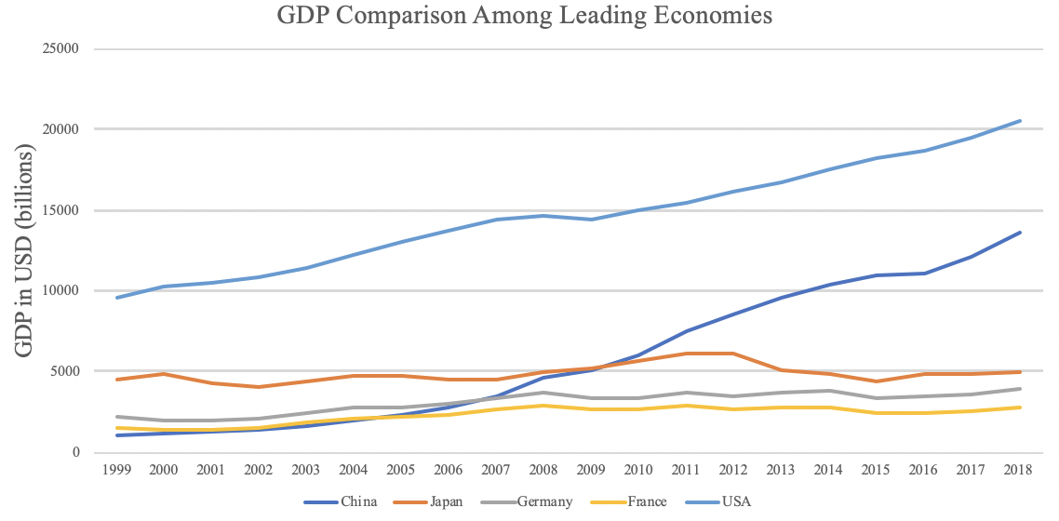

Figure 1: GDP Comparison Among Leading Economies

2.2 ECI Ranking and Changes
The Economic Complexity Index (ECI), as defined by Ricardo Hausmann and Cesar Hidalgo in 2009 to explain the knowledge accumulated in a country's population, exhibits a similar pattern for CountryX. As illustrated in Figure 2 below, CountryX exhibits a mild decrease in terms of its production capability from 2013 to 2018, which is true for most of the developed economies. This is in direct contrast to countries such as China, which demonstrates overwhelming advantage over CountryX in terms of both ECI and GDP growth during the period.

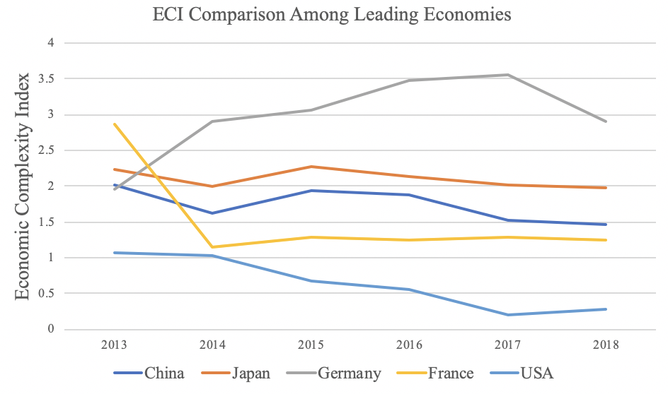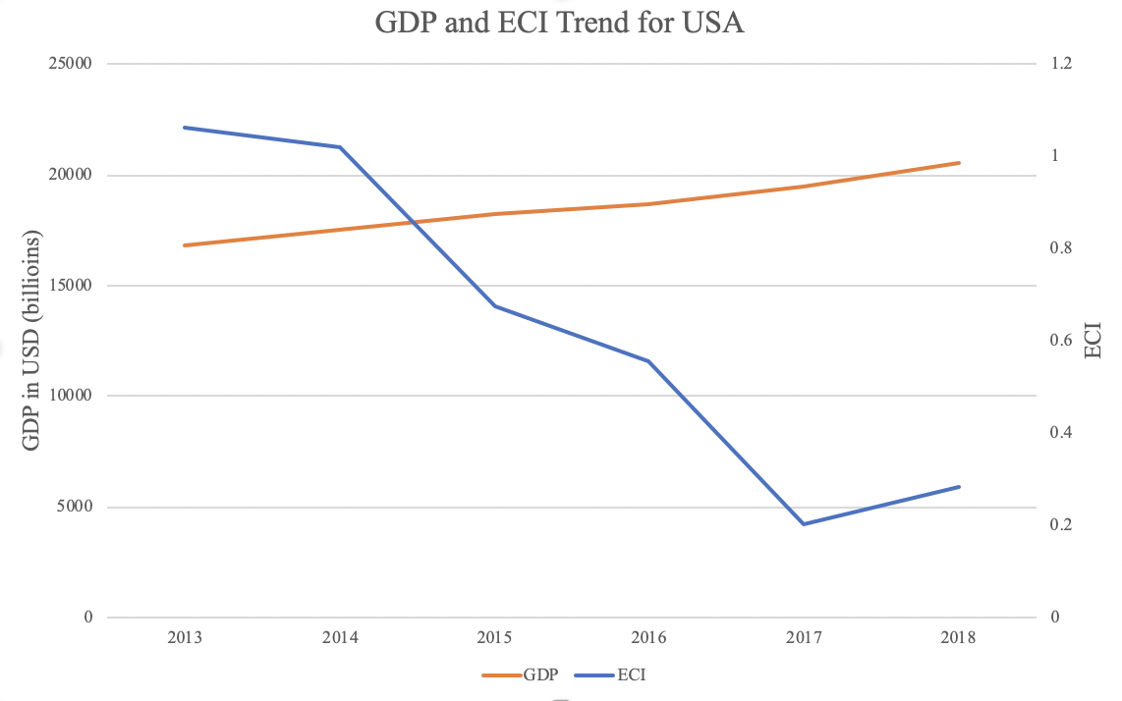

Figure 2: ECI Comparison Figure 3: GDP Growth and ECI (U.S.)

Figure 3 offers a further comparison of GDP Growth and ECI over the time span from 2013 to 2018 for U.S.. The stagnancy in GDP growth during the period from 2013 to 2018 is accompanied by a significant decrease in ECI. The results show that the economic growth experienced by the U.S. during the period from 2013 to 2018, though stable, is not very consistent with the predictions by ECI and the U.S. had not yet effectively developed a competitive product space that helps to accumulate complicated knowledge and technology. In order to provide a more concrete answer to why this has happened, we will dive into an analysis of U.S. 's production structure and its product space designs in the next few chapters.

